Score Nexus: A Dual-Sport Desktop Scorecard Application

Done by:
Arijit Mandal (RA2411056010253)
Parth Chhabra (RA2411056010284)
Sai Parate (RA2411056010288)

Under the guidance of

Dr. P. Varun
In partial fulfillment for the Course,

21CSC206P–ADVANCED OBJECT ORIENTED AND PROGRAMMING

In
Data Science and Business Systems



FACULTY OF ENGINEERING AND TECHNOLOGY SCHOOL OF COMPUTING
SRM INSTITUTE OF SCIENCE AND TECHNOLOGY
KATTANKULATHUR

NOVEMBER 2025

SRM INSTITUTE OF SCIENCE AND TECHNOLOGY
(Under Section 3 of UGC Act, 1956)

BONAFIDE CERTIFICATE

Certified that this is the minor project report for the course 21CSC206P ADVANCED OBJECT ORIENTED AND PROGRAMMING entitled "ScoreNexus: A Dual-Sport Desktop Scorecard Application" is the Bonafide work of Arijit Mandal (RA2411056010253), Parth Chhabra (RA2411056010284) and Sai Parate (RA2411056010288) who carried out the work under the professor’s supervision.

SIGNATURE SIGNATURE

Dr. P .Varun Dr. V. Kavitha
Assistant Professor Professor and HOD
Data Science and Business Systems Data Science and Business Systems SRM Institute of Science and Technology SRM Institute of Science and Technology Kattankulathur Kattankulathur

ABSTRACT

The ScoreNexus Project is a desktop-based application developed in Java, designed to digitalize and simplify live scorekeeping for both cricket and football matches. Built using the Java Swing framework, it offers a modern and intuitive user interface that allows users to manage match events in real time. The system provides a complete solution for tracking scores, player statistics, and match progress in an organized and efficient manner. Its user-centric design ensures easy accessibility and operation, even for non-technical users, making it ideal for use in local tournaments, college leagues, and community matches.
The backend of ScoreNexus integrates JDBC with SQLite to provide robust and reliable data persistence. Each match’s data—including team information, player performance, goals, runs, wickets, and disciplinary events—is stored in a structured database for later review or analysis. The modular architecture separates concerns between the user interface, data models, utility classes, and database operations, ensuring maintainability and scalability. Additional features such as Undo/Redo support, match summaries, and automated data saving enhance usability and performance during live scoring sessions.
Beyond simple scorekeeping, ScoreNexus bridges the gap between sports management and computer science education by demonstrating how real-world sports analytics can be implemented through programming. The system’s capability to export data as CSV and generate PDF reports enables detailed post-match analysis and record-keeping. This project showcases the application of software engineering principles—object-oriented programming, GUI design, and database integration—to solve a real-world problem, highlighting both its technical depth and practical impact in modern sports event management.

TABLE OF CONTENTS

S.NO. | CONTENTS | PAGENO.
1 | INTRODUCTION | 1
 | 1.1 Motivation | 1
 | 1.2 Objective | 2
 | 1.3 Problem Statement | 3
 | 1.4 Challenges | 4
2 | LITERATURE SURVEY | 5
3 | REQUIREMENT ANALYSIS | 6
4 | ARCHITECTURE & DESIGN | 8
5 | IMPLEMENTATION | 13
6 | EXPERIMENT RESULTS & ANALYSIS | 15
7 | CONCLUSION | 19
8 | REFERENCES | 20

INTRODUCTION

1.1 Motivation

As university students with a passion for both Computer Science and sports, we observed a persistent gap in local and amateur-level competitions. Scorekeeping is often a manual, paper-based process, which is prone to error, inefficient for real-time sharing, and provides no simple way for long-term data analysis. We were motivated to apply our CSE skills to solve this real-world problem.
This project aligns with several UN Sustainable Development Goals (SDGs):
SDG 3 (Good Health and Well-being): By providing accessible and professional tools for local sports, we encourage organized community activities, which in turn promote a healthy and active lifestyle.
SDG 4 (Quality Education): This project serves as a significant educational tool. It provides a practical, complex problem (managing two different sports' logic) for which we designed and implemented a software solution, enhancing our understanding of database design, UI/UX, and software architecture.
SDG 9 (Industry, Innovation, and Infrastructure): We are creating a piece of digital infrastructure. By innovating on the traditional scoreboard, we provide a tool that allows small-scale leagues and colleges to build a "data industry" around their own events, tracking player performance and match history over time.

1.2 Objective

The primary objective of this project is to design, develop, and deploy a unified, stand-alone desktop application that can function as a digital scorecard for both football and cricket.
The key sub-objectives include:
- To create a clean, intuitive, and modern user interface using Java Swing.
- To manage the distinct and complex scoring rules for both football and cricket.
- To ensure all match data, from team scores to individual player statistics, is persistently stored.
- To implement a robust database backend using JDBC and a lightweight SQLite database.
- To provide functionality for exporting all relevant game data into universally readable CSV files.

1.3 Problem Statement
Manual scorekeeping for amateur sports is an outdated and inefficient system that often leads to significant challenges in accuracy and data management. Paper-based scorecards are vulnerable to data loss, as they can easily be misplaced, damaged, or discarded after matches. Additionally, manual tallies are prone to human error, making it difficult to trace or correct mistakes once recorded. The absence of a digital system also means there is no historical data, preventing teams or organizers from aggregating player statistics or reviewing past match performances. Moreover, the traditional paper method lacks professionalism, failing to deliver the modern, digital experience that players, coaches, and audiences now expect. The ScoreNexus application effectively addresses these issues by offering a centralized, digital, and persistent scorekeeping system that ensures reliability, accuracy, and long-term data storage. It enhances the overall match experience with real-time updates, automatic data saving, and export capabilities for analysis, thus bringing a professional and efficient edge to local and amateur sports management.

4 Challenges
The primary challenge encountered during development was the successful implementation of the JDBC (Java Database Connectivity) API. This was a multi-faceted challenge:
• Schema Design: Designing two separate, normalized database schemas that could accurately represent the data models of two vastly different sports.
• Connection Management: Ensuring the application reliably established a connection to the SQLite database file, properly handled potential exceptions (like a missing JDBC driver), and securely closed all Connection, Statement, and ResultSet objects to prevent resource leaks.
• Dynamic SQL: Writing and executing correct, parameterized SQL queries to INSERT, UPDATE, and SELECT data in real-time as game events occurred. This was especially complex in the cricket module's enrollPlayersForMatch method, which required an INSERT ... ON CONFLICT (UPSERT) operation to avoid duplicate player entries.
- UI-DB Synchronization: Ensuring that every user action in the UI (like clicking "Add Goal") was instantly and accurately reflected in the database, and that the UI itself was updated to confirm the change.
LITERATURE SURVEY

In analyzing the existing landscape of sports scorekeeping, we identified three main categories of solutions:
- Professional Cloud Platforms (e.g., ESPN Cricinfo, OneFootball): These are large-scale, web-based systems designed for a global audience and professional media coverage. While comprehensive, they are not designed for local use, are not offline-first, and are far too complex for a college tournament or a game between friends.
- Mobile Applications (e.g., various App Store/Play Store apps): Many mobile apps exist for scorekeeping. However, they are often single-sport focused, designed for a single user (the "scorer"), and may lack robust data export features. A desktop application is superior for a central "scoring desk" setup, offering a larger screen, a more powerful UI, and easier file management.
- Spreadsheets and Manual Methods: This is the most common solution at the amateur level. While customizable, spreadsheets (like Excel or Google Sheets) are not designed for real-time event tracking, lack a user-friendly "scoreboard" interface, and require significant manual data entry and formula management.
Our survey revealed a niche for a free, offline-first, multi-sport desktop application that combines the user-friendliness of a dedicated app with the robust data capabilities of a database. ScoreNexus was built to fill this niche.

REQUIREMENT ANALYSIS

Functional Requirements
The system was required to perform the following functions:
- Game Creation: Allow the user to set up a new match (Football or Cricket) with all relevant parameters (team names, player lists, overs, duration, etc.).
- Event Recording:
  - Football: recordGoal, recordAssist, recordYellowCard, recordRedCard, performSubstitution.
  - Cricket: addRun, addBall, recordWicket, recordExtra (Wide, No-Ball), recordBoundary (4, 6).
- State Management:
  - Football: Manage a real-time game clock with start, stop, and half-time logic.
  - Cricket: Manage overs, balls, wickets, run-rate calculation, and innings changes.
- Data Persistence: createNewMatch, updatePlayerStats, addHighlight, endMatch. All core game data must be written to the database as it happens.
- Data Export: CSVExporter.export... methods must be able to query the database and write the data to three distinct CSV files (e.g., summary, timeline, player stats).
Non-Functional Requirements
- Reliability: The application must handle errors (like database connection failures) gracefully without crashing.
- Usability: The UI must be intuitive, requiring minimal training. We used the Nimbus Look-and-Feel and custom styling to create a modern, non-default Swing appearance.
- Portability: The application must run on any operating system (Windows, macOS, Linux) that has a Java Virtual Machine (JVM).
- Performance: UI interactions and database writes must be near-instantaneous.

Assets and Libraries
- sqlite-jdbc.jar: This is the single most critical external library. It is the JDBC driver that allows the Java application to communicate with the SQLite database file.
- Image Assets (/resources/):
  - app_icon.png/.ico: For the window frame and taskbar.
  - app_logo.png: For branding on setup and selection screens.
  - Action Icons: image_goal.png, image_assist.png, image_yellow_card.png, image_red_card.png, image_sub_in.png, image_sub_out.png for the football module.

ARCHITECTURE & DESIGN

The project follows a Model-View-Controller (MVC) design pattern to ensure a clean separation of concerns.
- Model (com.scorenexus.model): Represents the data and business logic. These are plain Java objects (or Records) like Player.java, Team.java (for Football) and MatchData.java, PlayerStats.java (for Cricket). They know nothing about the UI or the database.
- View (com.scorenexus.ui): The entire Java Swing user interface. This includes all JPanel and JFrame classes (GamePanel.java, CricketPanel.java) that the user interacts with. It is responsible for displaying data and capturing user input.
- Controller (com.scorenexus.main & com.scorenexus.db): Acts as the intermediary.
  - The main package (ScoreboardManager.java, ScoreNexusApp.java) manages the application flow (like CardLayout) and instantiates the other components.
  - UI panels (like GamePanel) also act as controllers, listening for button clicks.
  - The DatabaseManager.java class is a dedicated controller for all database operations, abstracting all SQL logic away from the UI.

Project Folder Structure
The project maintains a consistent package structure for both sports, allowing for modularity and easy maintenance.
ScoreNexus: Football
ScoreNexus/
|-- src/
| |-- com/
| |-- scorenexus/
| |-- db/
| | |-- DatabaseManager.java
| |-- main/
| | |-- ScoreNexusApp.java
| |-- model/
| | |-- Game.java
| | |-- GameEvent.java
| | |-- Player.java
| | |-- Team.java
| |-- ui/
| | |-- GamePanel.java
| | |-- PlayerCircle.java
| | |-- SetupPanel.java
| | |-- UIManagerDefaults.java
| |-- util/
| | |-- CSVExporter.java
|
|-- lib/
| |-- sqlite-jdbc.jar
|
|-- resources/
| |-- app_icon.png
| |-- app_logo.png
| |-- image_goal.png
| |-- ... (other action icons)

ScoreNexus: Cricket
ScoreNexus/
|-- src/
| |-- com/
| |-- scorenexus/
| |-- db/
| | |-- DatabaseManager.java
| |-- main/
| | |-- ScoreboardManager.java
| |-- model/
| | |-- MatchData.java
| | |-- MatchState.java
| | |-- PlayerStats.java
| |-- ui/
| | |-- AppColors.java
| | |-- CricketPanel.java
| | |-- CricketSetupPanel.java
| | |-- SelectionPanel.java
| |-- util/
| | |-- CSVExporter.java
|
|-- lib/
| |-- sqlite-jdbc.jar
|
|-- resources/
| |-- app_icon.ico

ScoreNexus: Architecture
- User (Actor): The person (coach, scorer, student) who interacts with the application.
- UI (View) - com.scorenexus.ui:
  - Component: This layer is built with Java Swing (JFrame, JPanel, JButton, etc.).
  - Files: CricketPanel.java, SetupPanel.java, GamePanel.java, PlayerCircle.java.
  - Role: This is the only layer the user directly interacts with. It is responsible for displaying all visual information (scores, players, timer) and capturing all user input (button clicks, drag-and-drop, text entry).
- Application Core (Controller) - com.scorenexus.main:
  - Component: This acts as the central coordinator for the application.
  - Files: ScoreNexusApp.java (Football), ScoreboardManager.java (Cricket).
  - Role: It manages the main application window (JFrame) and the CardLayout to switch between different panels (e.g., from SetupPanel to GamePanel). It receives data from the setup panels and uses it to initialize the main game panels.
- Data Models (Model) - com.scorenexus.model:
  - Component: A set of Java classes (POJOs or Records) that represent the application's data structure.
  - Files: Player.java, Game.java (Football) and MatchData.java, PlayerStats.java (Cricket).
  - Role: These objects are used to pass data between the UI and the database layer. For example, the SetupPanel creates a Game object, which is then passed to the GamePanel and the DatabaseManager.
- Persistence Layer (Controller) - com.scorenexus.db:
  - Component: A dedicated Java class that abstracts all database logic.
  - File: DatabaseManager.java.
  - Role: This is the only class in the entire application that is allowed to write or read from the database. It receives high-level commands from the UI (e.g., recordGoal(player)) and translates them into specific SQL queries (UPDATE, INSERT).
- Database Driver (Connector) - lib/:
  - Component: The JDBC (Java Database Connectivity) driver.
  - File: sqlite-jdbc.jar.
  - Role: This is the "translator" that allows the DatabaseManager's Java commands to be understood by the SQLite database. It manages the low-level connection and query execution.
- Data Storage (Physical) - root/:
  - Component: The physical file on the disk where all data is stored.
  - File: scorenexus_gamedata.db.
  - Role: This is the persistent SQLite database. It is a single file, making the application highly portable.
- Utilities Layer - com.scorenexus.util:
  - Component: A helper class for specific, non-core tasks.
  - File: CSVExporter.java.
  - Role: This component is called by the UI. It retrieves data (either from the Game model object or by calling the DatabaseManager) and writes it to a new file on the File System.
Data Flow Example (Football - "Add Goal")
This flow shows how all the components work together:
- User right-clicks on a PlayerCircle in the GamePanel (UI).
- The PlayerCircle (UI) shows a JPopupMenu. The user clicks "Add Goal."
- The GamePanel (UI) catches this event and calls two methods: a. It updates the player.addGoal() (Model) to reflect the change locally. b. It calls dbManager.logEvent(...) and dbManager.updatePlayerStats(...) (Persistence Layer).
- The DatabaseManager uses the JDBC Driver to execute an INSERT command into the timeline table and an UPDATE command on the player_stats table.
- The JDBC Driver writes these changes directly into the scorenexus_gamedata.db (Data Storage) file.
- The GamePanel (UI) calls findAndRepaintPlayerCircle(), which re-reads the data from the player (Model) and redraws the player with the new goal icon.

IMPLEMENTATION

The core of the application lies in its database implementation, which provides the persistence layer.
JDBC Connection and Database File
The DatabaseManager class in both modules is the only class that directly interacts with the database.
- Connection: It uses the JDBC connection string jdbc:sqlite:scorenexus_gamedata.db. This tells the JDBC driver to look for (or create) a file named scorenexus_gamedata.db in the root directory of the project.
- Table Creation: The createTables() method is called upon initialization. It executes CREATE TABLE IF NOT EXISTS ... SQL commands. This design makes the application self-contained; it does not require any external database setup.
Data Storage and Flow
When a new match is created, the data flows as follows:
- The user enters team and player names into the CricketSetupPanel or SetupPanel.
- On clicking "Start Game," the UI panel gathers this data into a model object (e.g., MatchData or Game).
- This model object is passed to the main application (ScoreboardManager or ScoreNexusApp).
- The main application calls dbManager.createNewMatch(data).
- Inside DatabaseManager:
  - A new row is inserted into the matches (or games) table.
  - The auto-incremented match_id is retrieved.
  - For Cricket, the enrollPlayersForMatch method iterates through the player lists. It first adds the player to the central players table (using ON CONFLICT DO NOTHING to prevent duplicates) and then uses the new player_id to create a blank row in the match_stats table, linking the player to the current match_id.
  - For Football, a similar process creates initial rows in the player_stats table for the new game.
- During the game, any action (like recordGoal or updatePlayerStats) calls a specific method in DatabaseManager (e.g., logEvent, updatePlayerStats). These methods use parameterized UPDATE queries, targeting the specific match_id and player_id to keep the data synchronized.
This implementation ensures that all match variables (team names, player stats, scores) are saved and associated with a unique match_id, allowing for robust historical data retrieval and export.

EXPERIMENTAL RESULTS AND ANALYSIS

ScoreNexus Start-Up Page
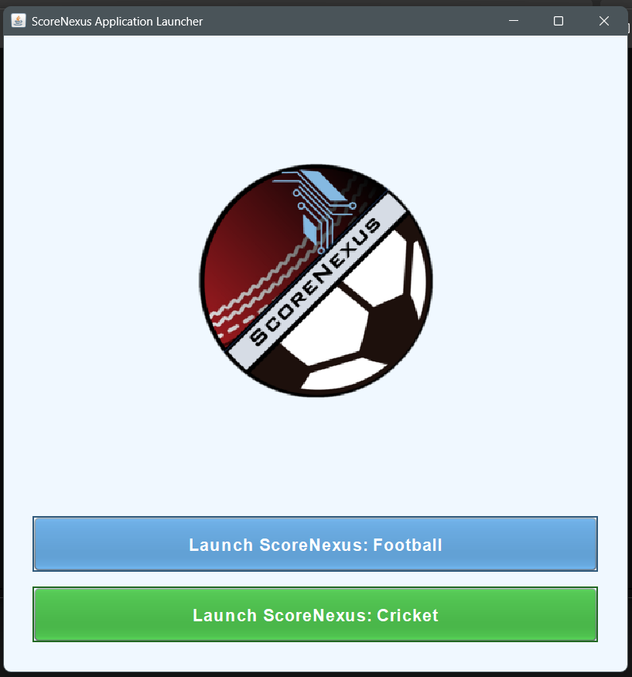
ScoreNexus Cricket Input Page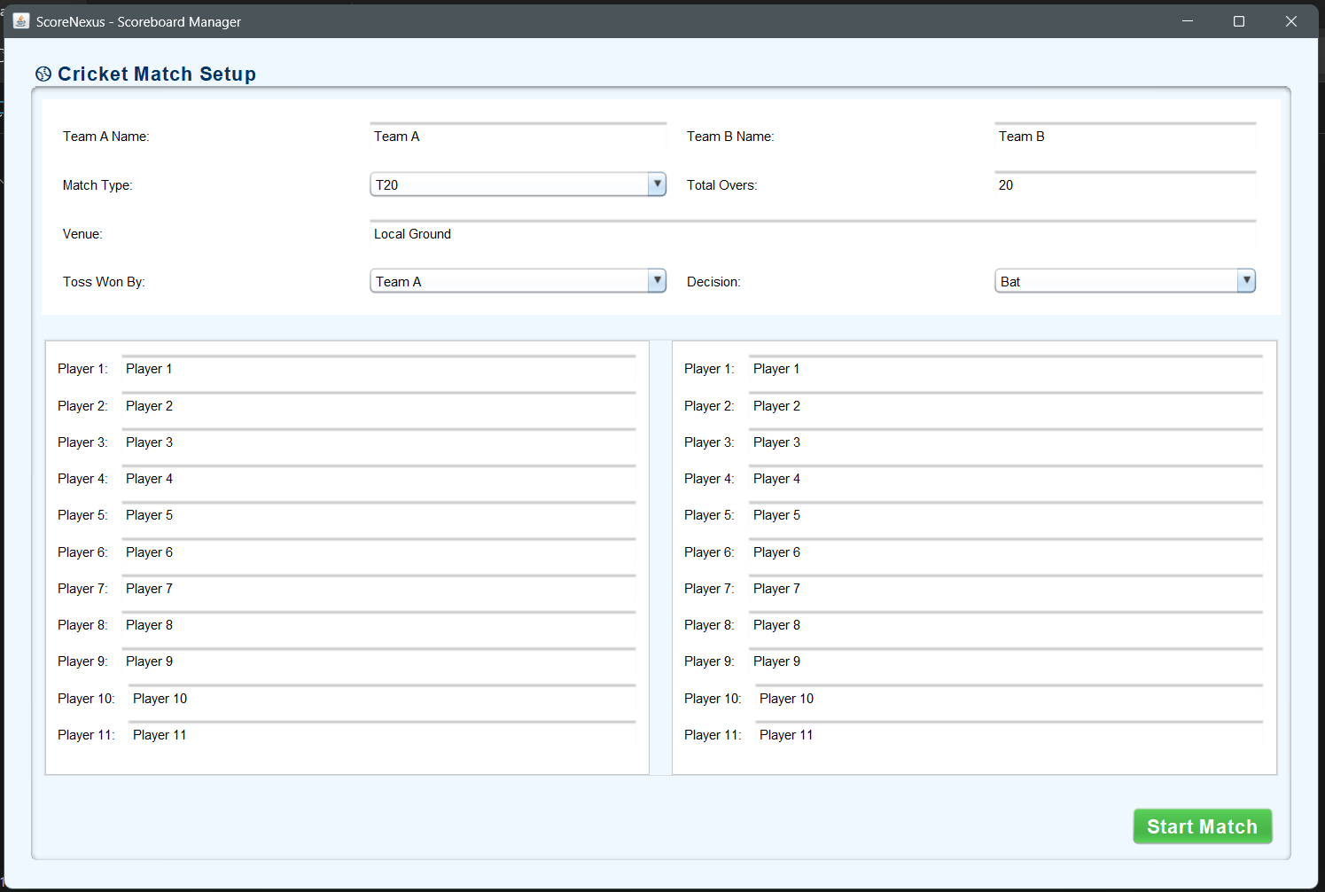
ScoreNexus Cricket Scoreboard Page
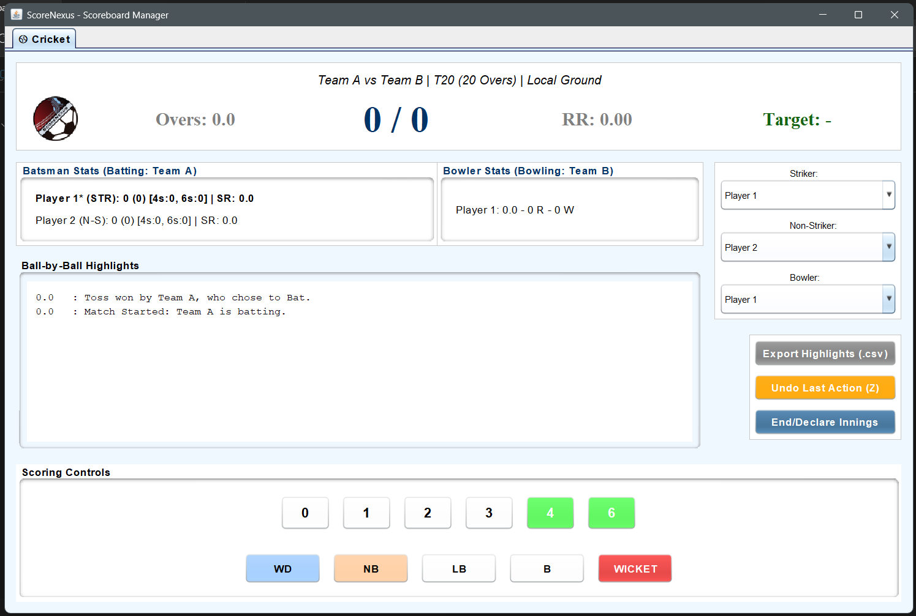
ScoreNexus Football Input Page
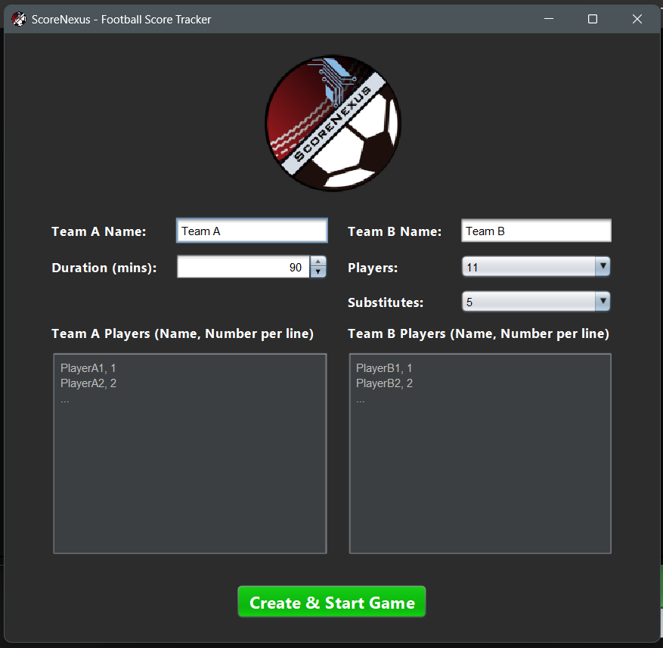
ScoreNexus Football Scoreboard Page
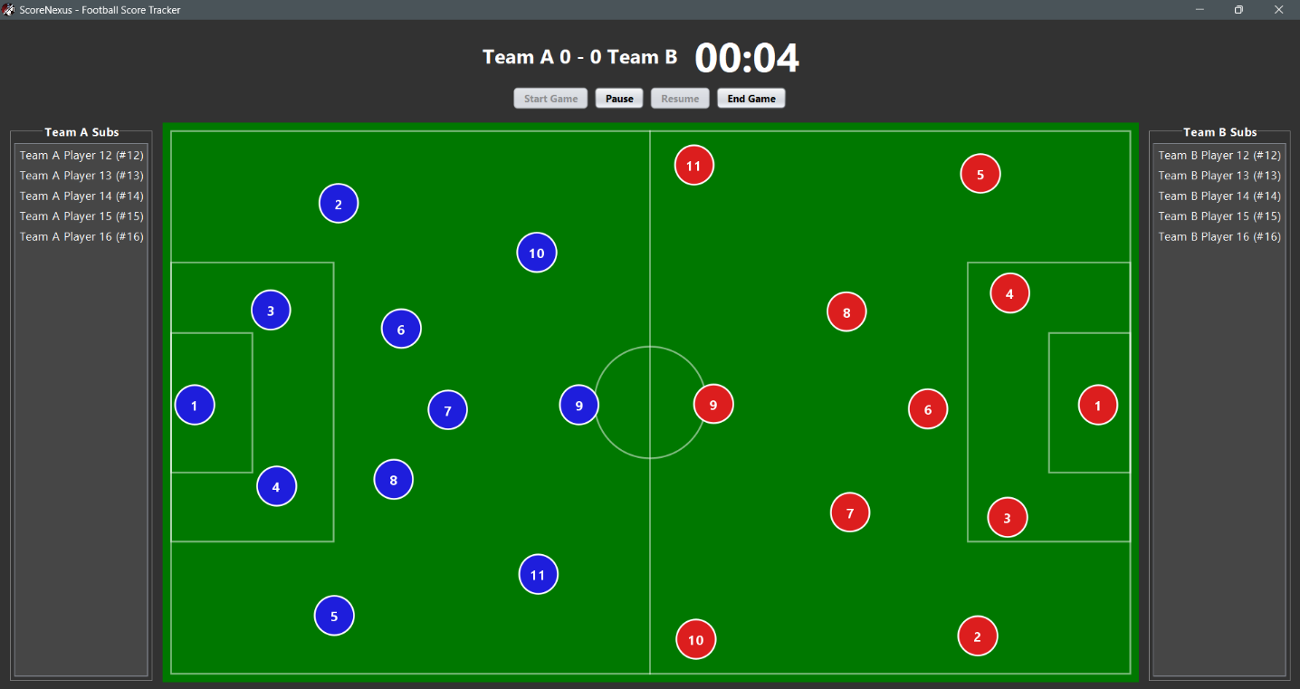
ScoreNexus Cricket SQL Implementation:
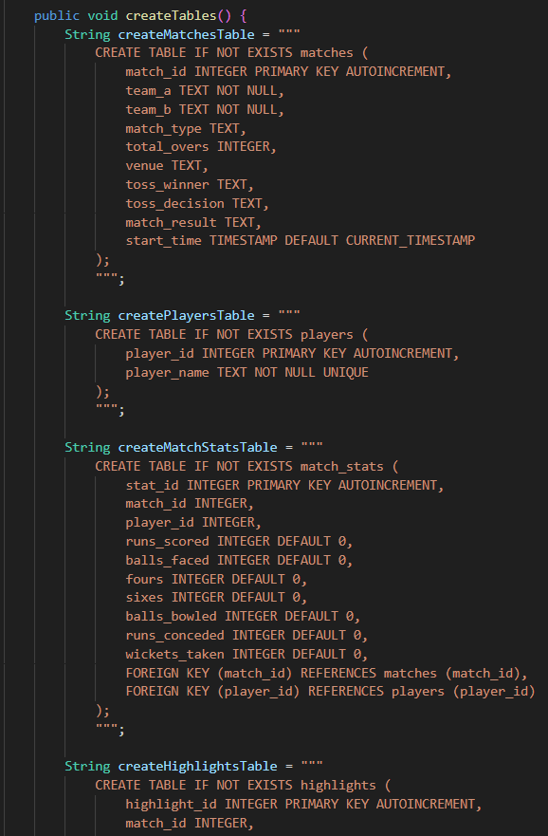
ScoreNexus Football SQL Implementation
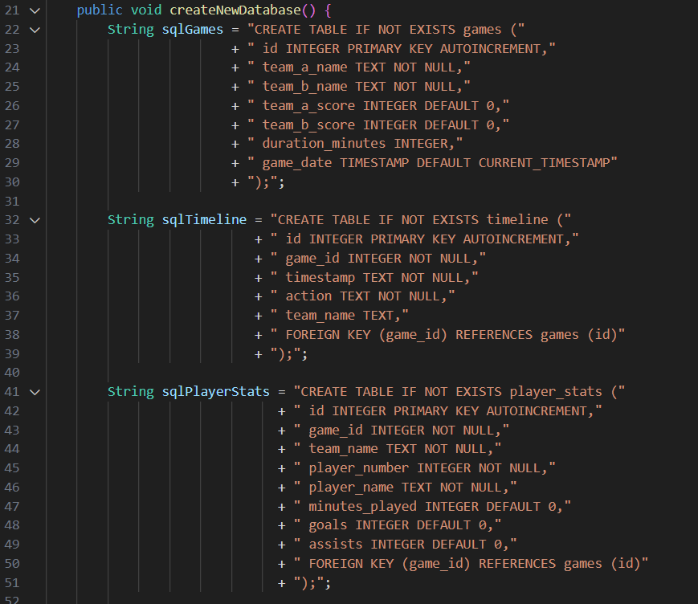

Testing was conducted with multiple sample users and datasets. The system was successful in performing all required operations like creating, editing, deleting plant entries, and generating maintenance reminders.

CONCLUSION

The ScoreNexus project successfully achieves its objective of creating a robust, dual-sport scorecard application. By leveraging Java Swing for the UI and a JDBC-SQLite backend for data persistence, it provides a valuable and practical tool that solves the problem of inefficient manual scorekeeping in amateur sports.
This project not only serves as a useful utility but also as a comprehensive academic exercise, demonstrating the practical application of database design, software architecture (MVC), and UI/UX principles to solve a real-world problem.
Future Work:
- Cloud Integration: The next logical step is to replace the local SQLite database with a cloud-hosted database (e.g., MySQL or PostgreSQL on a remote server) to allow for live, online score-tracking.
- Web-Based Interface: Re-platforming the application as a web app (using frameworks like Spring Boot and React) would make it universally accessible from any device.
- Expansion: The modular architecture allows for new sports (e.g., basketball, volleyball) to be added as new packages.

REFERENCES

- JDBC Reference. Java DB Documentation, Oracle, https://docs.oracle.com/javadb/10.8.1.2/ref/crefjdbc12657.html
- Javax Swing Summary. Java 8 API Specification, Oracle, https://docs.oracle.com/javase/8/docs/api/javax/swing/package-summary.html
- Oracle Java Documentation
- JFreeChart Library Documentation
- SQLite JDBC Driver (Xerial)
https://github.com/xerial/sqlite-jdbc
- Stack Overflow (Java & UI Solutions)
https://stackoverflow.com/questions/tagged/java-swing
- Java Swing Tutorial – GeeksforGeeks
https://www.geeksforgeeks.org/java-swing-tutorial
- SQLite Official Documentation
https://www.sqlite.org/docs.html
- JDBC (Java Database Connectivity) Guide – Oracle
Oracle Java Documentation
- Stack Overflow (UI solutions)

